**Circuit and System-I**



**Spring 2019**

Submitted by: **SHAH RAZA**

Registration No. : **18PWCSE1658**

Class Section: **B**

“On my honor, as student of University of Engineering and Technology, I have neither given nor received unauthorized assistance on this academic work.”

Student Signature: ______________

Submitted to:

**Engr. Muneeba Ashfaq**

Department of Computer Systems Engineering

University of Engineering and Technology, Peshawar.

**Title:**

“To find the resistance of a Resistor by color coding Method”

**Objectives:**

* To find the resistance of resistor by color coding method
* Also using the DMM for resistance measurement

**Resistor:**

A resistor is an electrical component that limits or regulates the flow of current in an electrical circuit. Resistors are very important parts of the circuit, without resistors voltage would be too great for individual components to handle and would result in overloading or destruction. Resistors are mostly made from small rods of ceramic coated with metal. The value of resistance is controlled by the thickness of the coating layer.

**Resistance:**

Resistance is the opposition that a substance offers to the flow of electric current.  It is represented by the uppercase letter R.

Mathematically:

R=V/I

**Unit:**

The standard unit of resistance is the [ohm](https://whatis.techtarget.com/definition/ohm), and sometimes symbolized by the uppercase Greek letter omega: Greek letter omega.

**Ohm (Greek letter omega):**

The SI unit of electrical resistance, transmitting a current of one ampere when subjected to a potential difference of one volt.

**Figure:**

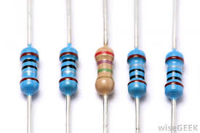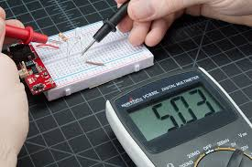

**Color coding Method:**

It is a method in which we used the color bands present on the body of a resistor,and find the resistance of that particular resistor the method is known as Color coding method.

Steps to Find the Resistance by Color coding Method:

* The resistor has four or more than four coloured bands on its body.
* The first two bands give the values of the resistance.
* The third band is the multiplier in power of ten of the value determined by first two colour bands.
* The fourth band gives the tolerance for the resistor.

The colour coding of the resistors can be remembered using the following: B B ROY Great Britain Very Good Wife. We will use all upper case letters.

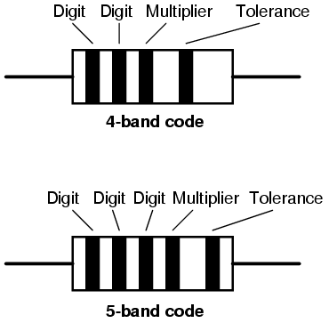Color band Values:

B = Black = 0

B = Brown = 1

R = Red = 2

O = Orange = 3

Y = Yellow =4

G= Green = 5

B= Blue = 6

V= Violet = 7

G = Grey = 8

W = White = 9

Fourth band is either Silver, Gold or no band at all.

Let the colour of four bands be Green Red Brown and Silver. Then it's value will be Green = 5, Red = 2, Brown = 10¹ ± Silver = 10%

**Table of color Codes:**

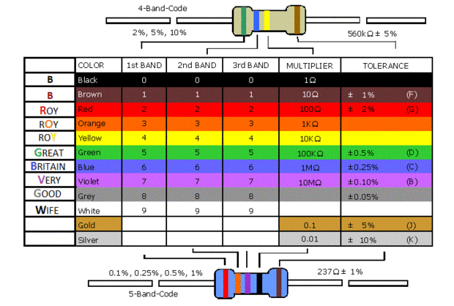

From the color coded table we can find easily the resistance of a given resistor.

**OBSERVATION and calculations:**

|  |  |  |  |  |  |  |
| --- | --- | --- | --- | --- | --- | --- |
| S.NO | 1st Band | 2nd Band | 3rd band | 4th Band | Range (±5% 0f Total R) | DMM |
| 1 | Orange(3) | Orange(3) | Brown(1) | Gold(±5%) | 313.5Greek letter omega---346.5Greek letter omega | 329Greek letter omega |
| 2 | Red(2) | Red(2) | Orange(3) | Gold(±5%) | 20900Greek letter omega ---23100Greek letter omega | 27.1 KGreek letter omega |
| 3 | Brown(1) | Black(0) | Red(2) | Gold(±5%) | 950Greek letter omega---1050 Greek letter omega | 1014 Greek letter omega |
| 4 | Yellow(4) | Violet(7) | Brown(1) | Gold(±5%) | 446.5Greek letter omega---493.5 Greek letter omega | 2.2k Greek letter omega |